# Programmer’s documentation for Monopoly game

Contents

Programmer’s documentation for Monopoly game 1

UML diagram of classes 1

Main classes of the project 1

Used libraries 2

## UML diagram of classes

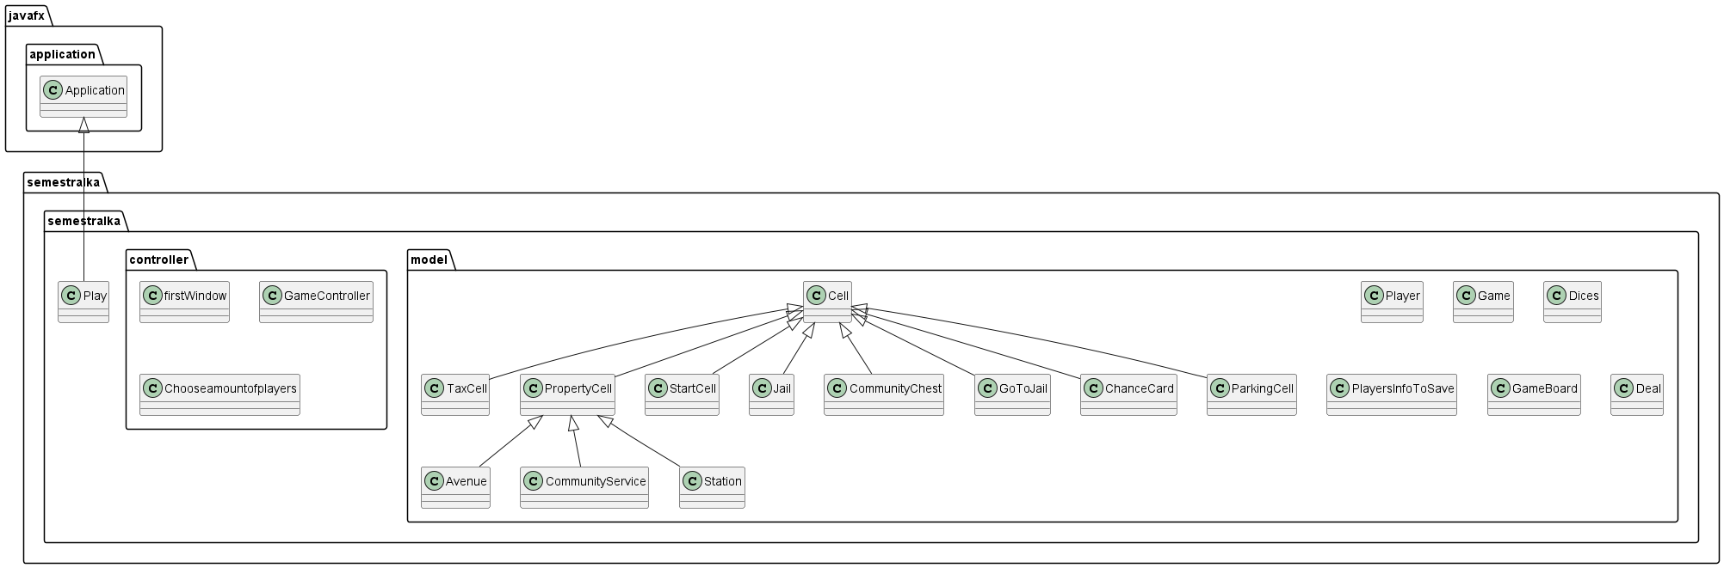

## Main classes of the project

1. Avenue - represents an Avenue property cell in the Monopoly game. Extends the PropertyCell class.
2. Cell - represents the cell on the gameboard in the Monopoly game.
3. ChanceCard - represents a Chance card in the Monopoly game. Extends the Cell class.
4. CommunityChest - represents a Community Chest card in the Monopoly game. Extends the Cell class.
5. CommunityService - represents a Community Service property cell in the Monopoly game. Extends the PropertyCell class.
6. Deal - represents a deal context between two players in the Monopoly game.
7. Dices - represents a pair of dices used in the Monopoly game.
8. Game - represents the game state of Monopoly.
9. GameBoard - represents the game board in the Monopoly game.
10. GoToJail - represents the "Go to Jail" cell in the Monopoly game. Extends the Cell class.
11. Jail - represents the "Jail" cell in the Monopoly game. Extends the Cell class.
12. ParkingCell - represents the "Free Parking" cell in the Monopoly game. Extends the Cell class.
13. Player - represents a player in the Monopoly game.
14. PlayersInfoToSave - represents the information of players to be saved.
15. PropertyCell - represents a property cell in the Monopoly game. Extends the Cell class.
16. StartCell - represents the "Start" cell in the Monopoly game. Extends the Cell class.
17. Station - represents a Station property in the Monopoly game. Extends the PropertyCell class.
18. TaxCell - represents a Tax Cell in the Monopoly game. Extends the Cell class.

## Used libraries

1. JavaFX
2. Jackson
3. Java Logging
4. Java I/O